Trader Behavior vs Market Sentiment .
Project Overview
This project analyzes the impact of market sentiment on cryptocurrency trader behavior. By combining Fear & Greed Index data with historical trade data, we identify patterns in trade direction, profitability, and trader segmentation. A machine learning model is also applied to predict trade direction based on trader and market features.
Objective:
Understand how market sentiment influences trader decisions.
Analyze performance differences between high-value vs low-value traders and frequent vs infrequent traders.
Predict trade direction using a supervised ML model.
Datasets
Fear & Greed Index
Contains daily sentiment classifications: Extreme Fear, Fear, Neutral, Greed, Extreme Greed.
Columns: timestamp, value, classification, date.
Historical Trade Data
Detailed trade logs including coin, size, PnL, side (BUY/SELL), fees, and timestamps.
Columns: Account, Coin, Execution Price, Size Tokens, Size USD, Side, Closed PnL, Timestamp IST, Fee, etc.
Note: Missing values were cleaned, and the datasets were merged on date.
Methodology
Data Cleaning & Preparation
Removed missing values from both datasets.
Converted date columns to datetime format.
Sampled trades (5000 records) for faster analysis.
Feature Engineering
Created win column → 1 if Closed PnL > 0, else 0.
Trader segmentation:
High-value traders → trades above median Size USD.
Low-value traders → trades below median Size USD.
Calculated metrics like Long/Short ratio, Average Trade Size, Total Trades.
Analysis
Sentiment analysis: mean PnL, win rate, and trade size per sentiment.
Segment analysis: performance of High vs Low traders across sentiments.
Frequent vs infrequent trader behavior analysis.
Visualization
Bar plots for PnL vs Market Sentiment and Win Rate vs Market Sentiment.
Histogram for Trade Size Distribution.
Feature importance chart from ML model.
Machine Learning

Model: Random Forest Classifier
Features used:
Numeric features: Execution Price, Size Tokens, Size USD, Fee, win, Trader Type, Coin, Total Trades
Target: Side (BUY = 1, SELL = 0)

Steps:
Encode categorical variables (Side, Trader Type, Coin).
Drop non-numeric/irrelevant columns.
Train-test split (80/20).
StandardScaler applied for normalization.
Random Forest Classifier trained (200 estimators, max depth = 10).

Model Performance:
Accuracy: 0.834
Top features influencing trade direction:
Execution Price
Total Trades
Win rate (win)
Key Insights
Traders perform best during Extreme Fear periods.
Greed periods show lower profitability and higher risk.
High-value traders exhibit higher volatility.
Frequent traders take more trades and show consistent performance.
Long/Short ratio shifts slightly with market sentiment.
Strategy Recommendations 🚀
Reduce leverage during Greed periods.
Trade cautiously during Extreme Fear.
Apply strict risk control for high-value traders.
Frequent traders can optimize trade size and timing based on market sentiment.
Conclusion
This project demonstrates the significant influence of market sentiment on trader behavior in the crypto market. By combining statistical analysis and machine learning:

Traders can identify optimal periods for profitable trading.
Market sentiment insights can help in risk management and trade timing.
ML model effectively predicts trade direction with strong accuracy.

✅ Project Completed Successfully!

# Trader Behavior vs Market Sentiment Analysis .

## Project Overview
This project analyzes the impact of market sentiment on trader behavior using historical trade data and Fear & Greed Index. It explores how traders perform under different market conditions and applies a machine learning model to predict trade direction.
---
## Dataset
1. **Fear & Greed Index (`fear_greed_index.csv`)**
- Columns: `timestamp`, `value`, `classification`, `date`
- Measures market sentiment from Extreme Fear to Extreme Greed.
2. **Trade Data (`historical_data.csv`)**
- Columns include: `Account`, `Coin`, `Execution Price`, `Size Tokens`, `Size USD`, `Side`, `Timestamp IST`, `Closed PnL`, `Fee`, etc.
- Contains historical trades from multiple traders.
---
## Data Cleaning & Preprocessing
- Checked for missing values: None found.
- Converted date columns to `datetime`.
- Merged sentiment and trade data on `date`.
- Created new features:
- `win`: 1 if trade `Closed PnL > 0`, else 0
- `Trader Type`: High if `Size USD > median`, else Low
- Aggregated metrics per sentiment and trader segment.
---
## Exploratory Data Analysis (EDA)
### Sentiment Analysis
| Classification | Avg Closed PnL | Win Rate | Avg Trade Size (USD) |
|-----------------|----------------|----------|--------------------|
| Extreme Fear | 101.71 | 0.367 | 6532.76 |
| Extreme Greed | 50.96 | 0.481 | 3030.95 |
| Fear | 45.87 | 0.423 | 8259.81 |
| Greed | -22.30 | 0.374 | 5641.99 |
| Neutral | 30.96 | 0.402 | 3874.96 |
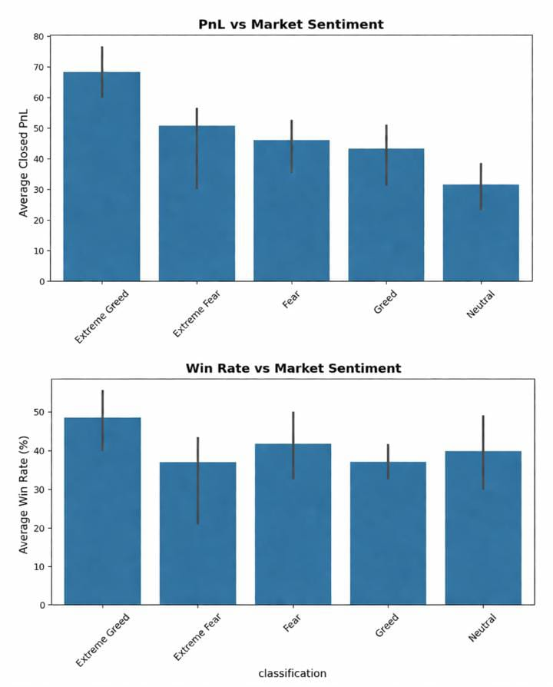

### Segment Analysis
- High-value traders show higher volatility.
- Low-value traders show smaller but consistent trades.
- Frequent traders execute more trades with slightly higher win rates.
## Key Insights
1. Traders perform best during **Extreme Fear** conditions.
2. **Greed** periods show risky or lower performance.
3. High-value traders show higher **volatility**.
4. Frequent traders take more trades and maintain consistent results.
5. Long/Short ratio changes slightly with market sentiment. 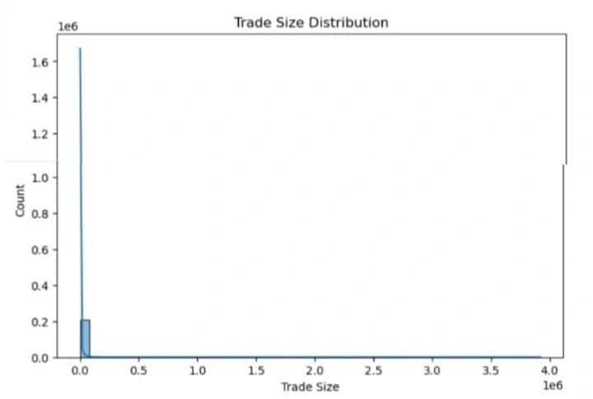
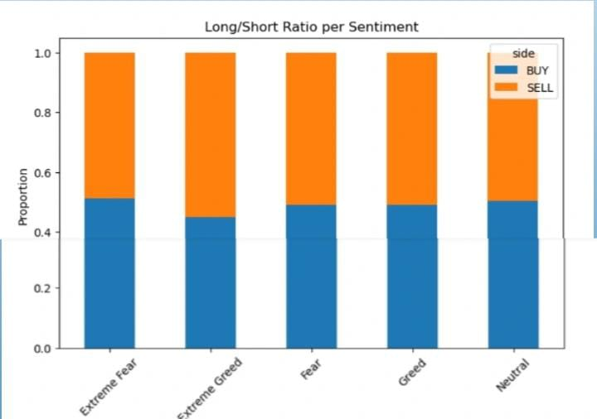
---
## Strategy Recommendations
1. Reduce leverage during **Greed** periods.
2. Trade cautiously during **Extreme Fear**.
3. Apply strict risk control for **high-value traders**.
4. Frequent traders can optimize trade size and timing based on sentiment.
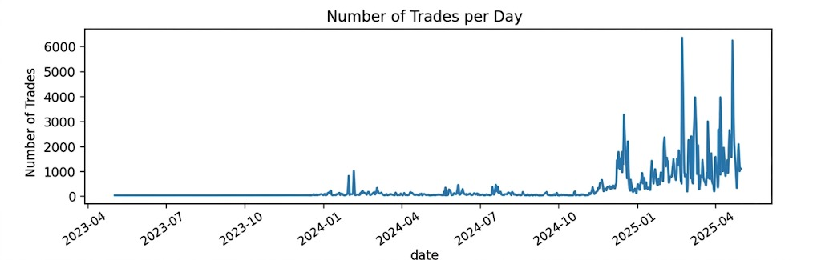
---
## Machine Learning Model
- **Model:** Random Forest Classifier
- **Target:** `Side` (BUY=1, SELL=0)
- **Features:** Execution Price, Size Tokens, Size USD, Fee, Coin, Trader Type, win, Total Trades, Value, Classification
- **Accuracy:** 83.4%
- **Top Features:**
1. Execution Price
2. Total Trades
3. Win
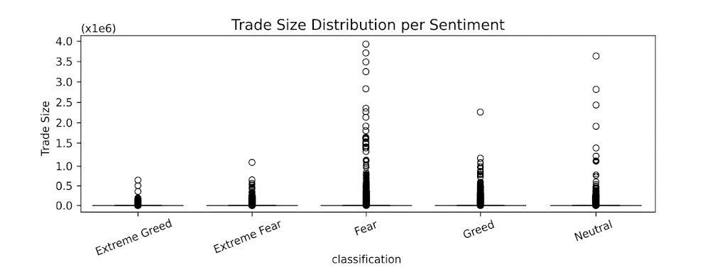
---
## Visualizations
> (You can add images/screenshots of these plots in your GitHub repository)
1. **PnL vs Market Sentiment**
2. **Win Rate vs Market Sentiment**
3. **Trade Size Distribution**
4. **Leverage Distribution** (if available)
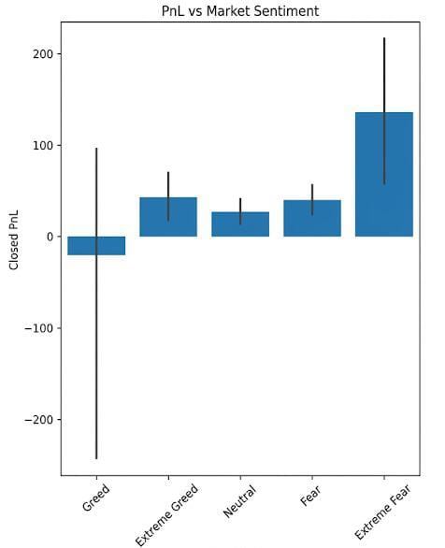

---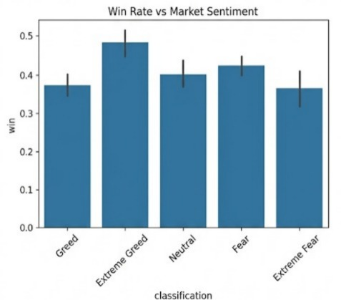
## Final Conclusion
- Market sentiment significantly impacts trader behavior.
- Extreme Fear conditions provide better profitability opportunities.
- Greed periods introduce higher risk and unstable returns.
- Frequent and high-value traders behave differently, which can be used to optimize strategies.
- Machine learning model predicts trade direction with good accuracy.
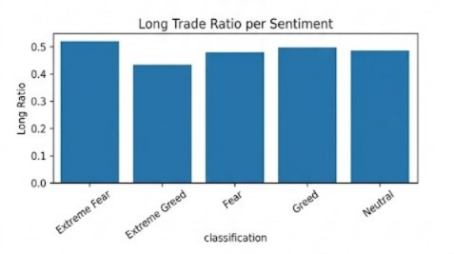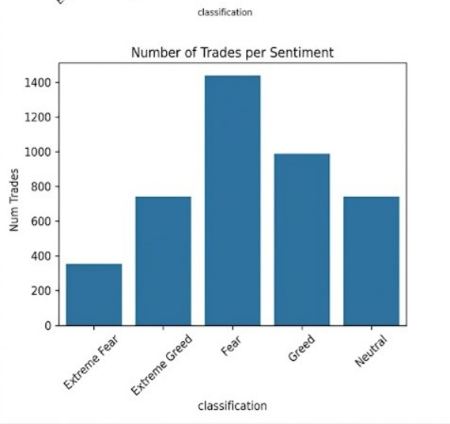
---
## Project Status
**Completed Successfully!**
---
## Contact
For any queries, reach out at my email or GitHub profile.
- Email: [akshithamadaramoni@gmail.com]
- GitHub / Notebook:
- [https://github.com/akshithamadaramoni/Trader-Behavior-vs-Market-Sentiment]

